**1) Are the HTML tags and elements the same thing?**

-> No both are different…HTML Tags are building blocks of HTML Page. HTML Elements are components that are used in HTML Page.

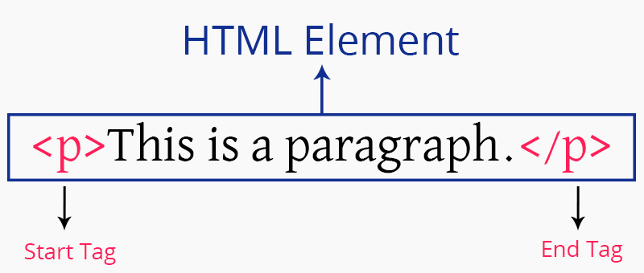

**2) What are tags and attributes in HTML?**

-> HTML tags are used to hold the HTML element. HTML element holds the content. HTML attributes are used to describe the characteristic of an HTML element in detail. HTML tag starts with < and ends with > Whatever written within a HTML tag are HTML elements.

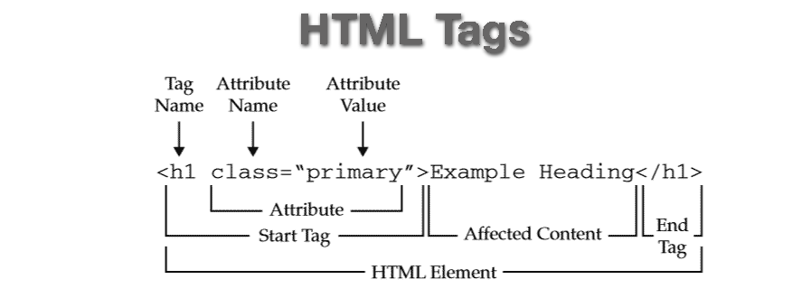

**3) What are void elements in HTML? With Example.**

-> There is a special group of elements that only have start tags and does not contain any content within it, these elements are called void elements. Void elements doesn’t have ending tags and can only have attributes but do not contain any kind of content. These elements can have backslash before ending of start tag but that is completely optional. Example of such elements are <br>, <hr>, <img>, <input>, <link>, <base>, <meta>, <param>, <area>, <embed>, <col>, <track>, <source> etc.

Characteristics:

* Void elements do not have end tags.
* Void elements cannot have content inside it.
* Void elements have attributes.
* Void elements cannot be nested.

**4) What are HTML Entities? With Example.**

-> An HTML entity is used to display invisible characters and reserved characters that would otherwise be interpreted as HTML code. It is a piece of text, or string, that begins with an ampersand ( & ) and ends with a semicolon ( ; ).

Example:

|  |  |  |  |
| --- | --- | --- | --- |
|  | non-breaking space | &nbsp; | &#160; |
| < | Less than | &lt; | &#60; |
| > | Greater than | &gt; | &#62; |
| & | ampersand | &amp | &#38; |

<!DOCTYPE html>

<html>

<body>

<h1>HTML Entity Example</h1>

<h2>The copyright sign: &copy;</h2>

</body>

</html>

**5) What are different types of lists in HTML? With Example**

**->** HTML lists allow web developers to group a set of related items in lists.

**There are three types of lists in HTML**

* Unordered list or Bulleted list (ul)
* Ordered list or Numbered list (ol)
* Description list or Definition list (dl)

**Example:**

**<ul>**

**<li>Coffee</li>**

**<li>Tea</li>**

**<li>Milk</li>**

**</ul>**

**<ol>**

**<li>Coffee</li>**

**<li>Tea</li>**

**<li>Milk</li>**

**</ol>**

**<dl>  
  <dt>Coffee</dt>  
  <dd>- black hot drink</dd>  
  <dt>Milk</dt>  
  <dd>- white cold drink</dd>  
</dl>**

**6) What is the ‘class’ attribute in HTML? With Example**

-> The class attribute specifies one or more classnames for an element. The class attribute is mostly used to point to a class in a style sheet. However, it can also be used by a JavaScript (via the HTML DOM) to make changes to HTML elements with a specified class.

Example:

<html>

<head>

<style>

h1.intro {

color: blue;

}

p.important {

color: green;

}

</style>

</head>

<body>

<h1 class="intro">Header 1</h1>

<p>A paragraph.</p>

<p class="important">Note that this is an important paragraph. :)</p>

</body>

</html>

**7) What is the difference between the ‘id’ attribute and the ‘class’ attribute of HTML elements? With Example.**

-> Difference between id and class attribute: The only difference between them is that “id” is unique in a page and can only apply to at most one element, while “class” selector can apply to multiple elements.

Example:

<!DOCTYPE html>

<html>

<head>

<style>

/* Style the element with the id "myHeader" */

#myHeader {

background-color: lightblue;

color: black;

padding: 40px;

text-align: center;

}

/* Style all elements with the class name "city" */

.city {

background-color: tomato;

color: white;

padding: 10px;

}

</style>

</head>

<body>

<h2>Difference Between Class and ID</h2>

<p>A class name can be used by multiple HTML elements, while an id name must only be used by one HTML element within the page:</p>

<!-- An element with a unique id -->

<h1 id="myHeader">My Cities</h1>

<!-- Multiple elements with same class -->

<h2 class="city">London</h2>

<p>London is the capital of England.</p>

<h2 class="city">Paris</h2>

<p>Paris is the capital of France.</p>

<h2 class="city">Tokyo</h2>

<p>Tokyo is the capital of Japan.</p>

</body>

</html>

**8) What are the various formatting tags in HTML?->** HTML Formatting is a process that allows us to format text to increase its visual appeal. Various HTML tags can change how text appears on a web page and make the text attractive. We can use HTML text formatting tags to bold, italicize, underlined text, and do more.

Example:

<b>,<i>,<u>,<sup>,<sub>,<del>,<ins>

**9) How is Cell Padding different from Cell Spacing? With Example.**

->

Cellpadding basically defines the space present between a table cell's border and the content present in it.

Cellspacing basically defines the space present between individual adjacent cells.

One can create it using the tag of HTML <table>, but it sets the type attribute to cellpadding.

Example:

!DOCTYPE html>

<html lang="en">

<head>

<meta charset="UTF-8">

<meta name="viewport"

content="width=device-width,

initial-scale=1.0">

<title>Document</title>

</head>

<body>

<table border="1"

cellpadding="4"

cellspacing="5">

<thead>

<td><span>Name</span></td>

<td><span>Age</span></td>

</thead>

<tbody>

<tr>

<td>Rani</td>

<td>30</td>

</tr>

<tr>

<td>Rajan</td>

<td>35</td>

</tr>

<tr>

<td>Akshaya</td>

<td>17</td>

</tr>

<tr>

<td>Ashick</td>

<td>13</td>

</tr>

</tbody>

</table>

</body>

</html>

10) How can we club two or more rows or columns into a single row or column in an HTML table? With Example.

->It can be done by using the rowspan and colspan attribute in HTML.

The rowspan is used to merge or combine the number of cells in a row, whereas the colspan is used to merge column cells in a table.

Example:

<!DOCTYPE html>

<html>

<head>

<title>table</title>

</head>

<body>

<h2>Tables in HTML</h2>

<table border=”2”>

<tr>

<th >First Name </th>

<th>Job role</th>

</tr>

<tr>

<td >Tharun</td>

<td rowspan="2">Content writer</td>

</tr>

<tr>

<td >Akshaj</td>

</tr>

<tr>

<td colspan="2">Welcome to the company</td>

</tr>

</table>

</body>

</html>

11) What is the difference between a block-level element and an inline element?

->Block elements :

A block-level element always starts on a new line, and the browsers automatically add some space (a margin) before and after the element.

A block-level element always takes up the full width available (stretches out to the left and right as far as it can).

Two commonly used block elements are: <p> and <div>.

The <p> element defines a paragraph in an HTML document.

The <div> element defines a division or a section in an HTML document.

-> Inline elements:

An inline element does not start on a new line.

An inline element only takes up as much width as necessary.

This is a <span> element inside a paragraph.

**12)** **How to create a Hyperlink in HTML? With Example.->** The HTML <a> tag defines a hyperlink.

It has the following syntax:

<a href="url">link text</a>

The most important attribute of the <a> element is the href attribute, which indicates the link's destination.

The link text is the part that will be visible to the reader.

Clicking on the link text, will send the reader to the specified URL address.

**13) What is the use of an iframe tag? With Example.**

**->** An inline frame (iframe) is a HTML element that loads another HTML page within the document.

It essentially puts another webpage within the parent page.

They are commonly used for advertisements, embedded videos, web analytics and interactive content.

Example:

<!DOCTYPE html>

<html>

<body>

<h1>The iframe element</h1>

<iframe src="https://www.w3schools.com" title="W3Schools Free Online Web Tutorials">

</iframe>

</body>

</html>

**14) What is the use of a span tag? Explain with example?**

-> In HTML, the span tag is a generic inline container element.

You use this element to wrap sections of text for styling purposes or to add attributes to a section of text without creating a new line of content.

It is similar — but not the same as — the <div> tag.

Example:

<!DOCTYPE html>

<html>

<body>

<h1>The span element</h1>

<p>My mother has <span style="color:blue;font-weight:bold">blue</span> eyes and my father has <span style="color:darkolivegreen;font-weight:bold">dark green</span> eyes.</p>

</body>

</html>

**15) How to insert a picture into a background image of a web page? With Example.**

->

Using HTML:

<!DOCTYPE html>

<html>

<head>

<title>How to add an image as background image of a web page?</title>

</head>

<body background="image.jpg">

<h4>How to add an image as background image of a web page?</h4>

</body>

</html>

Using CSS:

<!DOCTYPE html>

<html>

<head>

<title>How to add an image as background image of a web page?</title>

<style>

body {

background-image: url("https://www.tutorialspoint.com/images/logo.png");

}

</style>

</head>

<body>

<h4 style="background-color: white;">How to add an image as background image of a web page?</h4>

</body>

</html>

**16) how are active links different from normal links in html?**

->Normal links are links which are there on the page and have not been clicked yet.

Active links are those links, which have just been clicked at that instant.

**17) What are the different tags to separate sections of text?**

**->We separate a section of texts in HTML using the below tags:**

* <br> tag – It is used to separate the line of text. It breaks the current line and shifts the flow of the text to a new line.
* <p> tag–This tag is used to write a paragraph of text.
* <blockquote> tag–This tag is used to define large quoted sections.

**18)** **What is SVG?**

**->** SVG stands for Scalable Vector Graphics. SVG defines vector-based graphics in XML format.

**19)** **What is difference between HTML and XHTML?->**

* HTML stands for Hypertext Markup Language, whereas XHTML stands for Extensible Hypertext Markup Language.
* XHTML is basically an extension of HTML, which is stricter than HTML.
* Both languages are used to create web and Android applications.
* HTML is SGML based, whereas XHTML is an XML-based language.

**20) What are logical and physical tags in HTML?**

* Physical tag: These tags are used to provide the visual appearance to the text.
* Logical tag: These tags are used to add some logical or semantic value to the text.

physical tags: <abbr>,<address>,<code>,<ins>,<del>,<pre>,<strong>

logical tags: <b>,<big>,<small>,<i>,<u>…..